WASHOE COUNTY FUND EXPENDITURE PLAN - CORONAVIRUS RELIEF FUNDS
July 31, 2020
Problem Statement: Coronavirus (COVID-19) is an illness caused by a virus that can spread from person to person. Prior to the first confirmed case of Coronavirus in Washoe County, the Washoe County Health District began actively preparing for a COVID-19 outbreak. In January, the Health District began working with local and regional partners, as well as the CDC, to prepare. They adapted two existing plans – Quarantine and Isolation Plan and Pandemic Flu Plan – which were adjusted to COVID-19.
By late February, Washoe County began considering the need for employees to work from home. On March 12, 2020 Governor Sisolak declared a state of emergency in the State of Nevada to respond to the spread of COVID-19. County departments began transitioning to remote work on March 16, 2020. Consistent with Governor Sisolak’s direction, on March 18th Washoe County suspended all non-essential government events, business meetings and business activities. Public facing non-essential County offices closed and non-essential County staff began to work remotely. On March 20, 2020 the Washoe County COVID-19 Incident Management Team (WCCOVID19 IMT), a collaborative team including Washoe County, the Washoe County District Health, the City of Reno, and the City of Sparks and was formed pursuant NRS 277.180(1), to respond to the COVID-19 pandemic.
The State of Nevada stay-at-home directive, and social distancing measures have had a significant impact on the economy of Washoe County; resulting in substantial unemployment reaching a record high of 20.4% in April, currently at the rate of 16%.
As of July 29, 2020
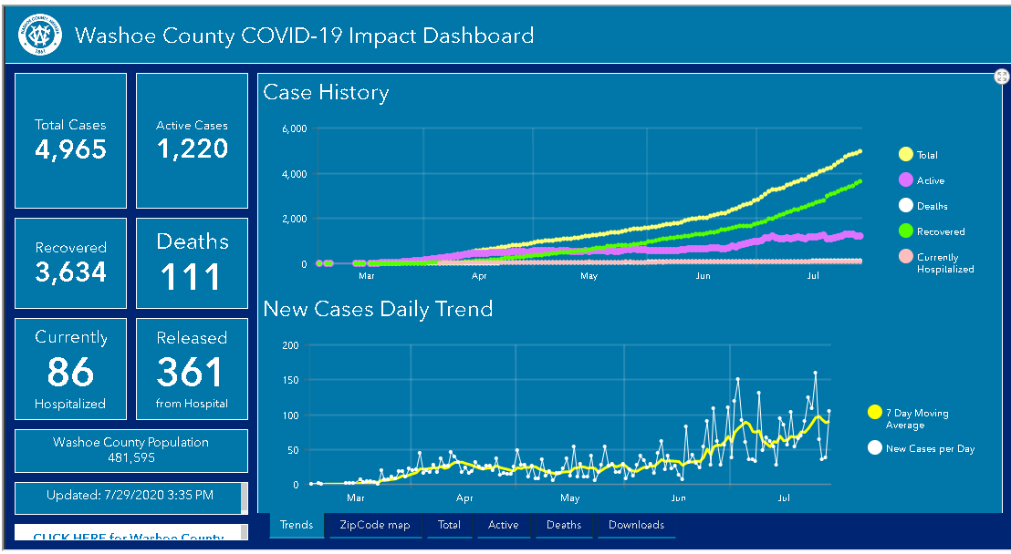
Estimated Amount of Funds Required: $10,127,409
Overview of CRF-CARES Funding - Direct response to the COVID Public Emergency:
In order to protect public health and to ensure public safety, as well as to lessen or avert the threat of a healthcare catastrophe, Washoe County through its offices and departments worked to prevent the spread of the virus, and to prepare for and respond to the outbreak.
Regional Response:
The CARES Act- Coronavirus Relief Funding is needed to support costs to respond directly to the outbreak through our regional Incident Management Team, Washoe County District Health and Washoe County. These costs include – IMT regional response, testing, contact tracing, Alternate Care sites, and quarantine sheltering. Total regionally shared expenses from March 1, through June 30 are $7,361,072. The regional costs will be shared among the three jurisdictions – Washoe county, City of Reno and City of Sparks, a portion of the costs will be submitted to the State of Nevada Department of Emergency Management for FEMA-PA grant reimbursement. Washoe County’s share of these regional costs is $2,392,634, for March – June; and $3,567,334 of new costs through August 31. Washoe County intends to use CARES- CRFs for these costs.
Total Regional Costs Allocated by Agency March - June:
Washoe County | $2,392,634
City of Reno | $1,674,844
City of Sparks | $717,790
FEMA (Pending) | $2,575,804
Total Regional Costs | $7,361,072
Regional Response - New Costs/Encumbrances by August 31
Edison Quarantine Facility - Final costs | $1,270,000
Handwash stations/Porta-potties | $6,000
WellCare Quarantine /Medical beds thru Oct. | $204,600
Total ongoing/encumbered | $1,480,600
New Costs:
Personal Protective Equipment | $2,500,000
Testing and Contract Tracing | $6,000,000
Small Business Assistance | $4,500,000
Homeless Asst. for Social Distancing | $700,000
Public Outreach Marketing Campaign | $300,000
UNR Wastewater Research | $1,800,000
Total new costs | $15,800,000
Total New Regional Costs: | $17,280,600
Total Regional Costs/Encumbrances by Sept. 1: | $24,641,672

CRF- CARES Funds to be used for the following: (Summery overview by category include Washoe County’s share of regional costs – noted as (R))
Medical Expenses: CRF funds will be used for $1,839,719 in expenses to cover medical needs including: Testing and contact tracing $1,593,229(R), Alternate Care Facility $197,386(R), and Quarantine/Medical Care $49,104(R).
Public Health Expenses: CRF funds will be used for $4,642,388 in public health expenses including: Quarantine facility-Edison $2,128,472 (R), Personal Protective Equipment (PPE) $600,000(R), Incident Management Team Regional Response $218,346(R), Homeless Assistance for Social Distancing/Sanitation $169,440(R), Public Outreach $72,000(R), COVID Wastewater study $432,000(R). Disinfection of public areas and other county facilities $345,000, Public Safety Measures for Medical Examiner and District Court $567,004, and PPE and sanitizing products for Registrar of Voters.
Payroll Expenses: CRF funds will be used for $1,157,748 in expense to cover payroll expense including: $981,745 for Public Safety personnel, and $176,002 for Human Services personnel.
Facilitate Compliance with Public Health Measures: CRF funds will be used for $1,987,554 in expenses to cover public health measures including: $110,000 for food access and delivery, $1,441,819 to improve telework capabilities for county employees, $197,811 for improvement of social distancing measures, and $200,000 for improvement of sanitation and social distancing measures at the Washoe County Detention Center.
Economic Support: CRF funds will be used for $500,000 of economic support to small businesses in collaboration with the cities of Reno and Sparks.
Regional and County expenses needed to prevent the spread of the virus, prepare for and respond to the outbreak total an estimated $10,127,409 between March 1 – August 31, 2020.
Medical Expenses: | $1,839,719
Public Health Expenses: | $4,642,388
Payroll Expenses: | $1,157,748
Facilitate Compliance Public Health Measures: | $1,987,554
Economic Support: | $500,000
 | $10,127,409

Names of Programs within Washoe County that will administer and use funds:
Alternate Public Defender
Animal Services
Clerk’s Office
Community Services Department
Comptroller
District Attorney’s Office
District Court
Human Services Agency
- Child Protective Services
- Adult Services
- Senior Services
Juvenile Services
Library System
Medical Examiner
Office of the County Manager
- Emergency Management
- Grants Management
- Security
- Communications
Registrar of Voters
Treasurer
Technology Services
Washoe County Health District
Washoe County Sheriff’s Office

Allocations to Other Entities:
Washoe County plans to sub-grant CRF funds to the City of Reno to provide an allocation of $500,000 to the regional Small Business Assistance Program administered by the City of Reno. The County also intends to provide a subgrant of $95,000 to support the Delivery with Dignity Reno-Sparks. With the second 50% of CRF funding, the County may allocate sub-grants to non-profit entities, and/or other governmental entities to prevent the spread of the virus, to prepare for, or respond to the outbreak.
Compliance with Federal Guidance:
Washoe County has established a team of financial management and grants management professionals. Our team includes our Assistant County Manager for Finance and Administration, Christine Vuletich, Comptroller, Cathy Hill, Budget Manager, Lori Cooke and County Grants Administrator, Gabrielle Enfield.
Christine Vuletich has served in public finance and management of local governments for more than 25 years. Her education includes a Master of Business Administration with a concentration in General Management from Golden Gate University, and a Bachelor of Science, Cum Laude, with a concentration in Finance from California State University, Sacramento.
Cathy Hill has over 25 years’ experience in accounting including public, private and not for profit. She holds a certification in professional human resources, acquired her Bachelor of Science in Accounting from the University of Nevada, Reno (UNR) and a Master of Business Administration from UNR as well.
Lori Cooke has over 20 years of public service experience at Washoe County. Her education includes a Master of Business Administration from the University of Nevada (UNR) and a Bachelor of Science in Business Administration from Oregon State University. She also earned her Certified Grants Management Specialist credential from the National Grants Management Association.
Gabrielle Enfield has over 28 years of experience managing federal funds for public entities including: county government, a school district, and two universities. Her education includes a Master of Public Administration, from the University of Idaho. She also earned a Certified Grants Management Specialist credential from the National Grants Management Association, a Grant Professional Certified credential from the Grants Management Association and holds a Grants Management Certificate – Recipient Track from Management Concepts.

Washoe County annually expends approximately $40,000,000 in federal funds. Our federal grants management compliance is supported by the Washoe County’s Grants Management Unit in the Office of the County Manager. Financial management for all grant funds is supported by the Office of the Comptroller. Grant related staff throughout Washoe County are familiar with federal guidelines, complying with Uniform Guidance - 2 CFR Part 200, and Washoe County’s Grants Management Policy Manual. Washoe County uses eCivis Grant Management software system for tracking and workflow.
All expenses identified for reimbursement from CRF funds will be reviewed and evaluated for compliance by the Comptroller, Cathy Hill and/or County Grants Administrator, Gabrielle Enfield.
To ensure compliance with the federal guidance for CRF subgrants allocated to other entities, the County Grants Administrator will manage the sub-recipient risk assessment, subgrant process, sub-recipient monitoring, allowable expenses, and close-out.

